Water-Tribe

IS 302

**Software Needed**

The only we software need is Webflow for database and CMS functionality. Webflow at least requires an account with CMS support and at minimum it must be hosted on Webflow. Options to use custom domain is possible if you add a site plan with this feature. Requires payment. Administrator (Zhenya Weston) has a working account with CMS support.

**How to set up the website and how to start it**

To set up website you only have to publish it when you think that the website is ready for deployment or testing.

Steps to publish a website on Webflow:

1. Login to webflow account
2. Choose the project you want to publish from the dashboard

1. Click on the project you want to publish to open it in designer tool

1. Click publish menu in top right corner

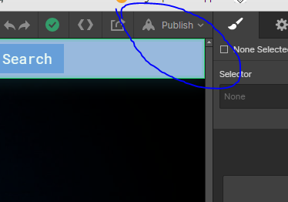

1. Choose an option where you want to publish. If you don’t have site plan, then you only can use webflow.io option

1. After publishing it, go back to dashboard and click on the project’s link to the live website. You also ca type the same link into web browser and it will take you to the website.

**How to add new individuals to the website and remove individuals from the website**

1. Users can be added and removed by creating new members inside of CMS
2. The are a couple ways to add members to the CMS. One is through designer and other using the editor. Editor mostly used for team collaboration when multiple users can edit the website and database entries (only if you are on team plan)

Click on CMS icon and choose CMS collection you want to edit. Team members collection is the choice in this example

1. Add new team member

1. Edit entry fields as required

1. To remove a member, click select and select user database you want to delete

**How team members can update their information**

1. At this point the team members can’t edit their information without administrator account. However, it’s possible to create team plan that can allow multiple users to work and collaborate on the same project at the same time and edit the CMS/database.